OudhTrade
Database Design
Module 2 — Identity & Security · M02-5
Document details
Company | MRIDA INFRA AND PLANTATIONS LLP
Product | OudhTrade — oudhtrade.com
Document | M02-5 Database Design
Module | M02 Identity & Security (release R1; some items R2)
Readers | Backend developers, DBA, tech lead
Related documents | PRD (PRD-IDN, PRD-CMP) · HLD · NFR · other M02 documents
Owner | Tech lead
Decision owner | T. Satish Reddy, CEO & Founder
Status | Draft for review — 24 September 2026
Classification | Confidential — for partners and the OudhTrade team

Contents
1. Overview 2
1.1 Standard columns 3
1.2 Data sensitivity 3
1.3 How to read the table diagrams 4
2. Accounts and Staff 5
2.1 accounts 5
2.2 staff_users 8
2.3 account_state_history 9
3. Sign-up, Legal Acceptances and Sign-in Links 9
3.1 invitations 9
3.2 waitlist_entries (removed) 10
3.3 legal_acceptances 10
3.4 consents 11
3.5 external_identities 12
4. Devices, Security, Recovery and Risk 12
4.1 trusted_devices 13
4.2 security_events 13
4.3 recovery_requests 14
4.4 contact_changes 15
4.5 risk_flags 15
4.6 disposable_email_domains 16
4.7 number_reclaims 16
5. Delegation, Nominee and Data Requests 17
5.1 delegations 17
5.2 nominees 18
5.3 data_requests 18
6. Partner and AI-Agent Access 19
6.1 api_clients 19
6.2 api_grants 20
7. Links to Other Modules 20
8. Retention Summary 21
9. Rules 22
10. Indexes and Volumes 22
11. What Lives in Keycloak and Redis Instead 23

1. Overview
Module 2 has 19 tables in PostgreSQL in a schema named `identity`. Other modules refer to them only by ID through Module 2 interfaces (M02-3 Section 3). Tables follow the Master Database Design standards (naming, IDs, data types, partitioning). IDs are UUID version 7 (time-ordered), except the high-volume security_events log (bigint identity) and one reference list with a natural key (disposable_email_domains).
Passwords, one-time-code secrets, authenticator and passkey credentials, backup codes and sessions are not in this schema: they live in Keycloak, which has its own small RDS PostgreSQL database (HLD 5.2 and 6.1). Section 11 lists what lives in Keycloak and in Redis instead.

1.1 Standard columns
Columns | On which Module 2 tables
created_at / created_by | All tables (append-only tables — account_state_history, legal_acceptances, consents, security_events — have created_at only, or their own time column)
updated_at / updated_by | All tables whose rows change
row_version | Tables edited by users or staff: accounts, staff_users, invitations, recovery_requests, number_reclaims, risk_flags, disposable_email_domains, delegations, nominees, data_requests, api_clients
anonymised_at | accounts, invitations, legal_acceptances, consents, recovery_requests, contact_changes, number_reclaims, nominees, data_requests (set when the account is anonymised after closure)
active | disposable_email_domains (reference data: retired, never deleted)

Standard columns are not repeated in the tables below unless a table uses them in a special way. `created_by` and `updated_by` hold an account, staff user or fixed system ID (Master Database Design, Section 4.3).
Natural key. Only `disposable_email_domains.domain` uses its natural value as the primary key. It is a reference list that nothing links to by a hidden ID, so it follows the reference-data exception of the Master Database Design (Sections 4.2 and 4.5). All other tables use `id uuid` (security_events uses bigint identity because it is an append-only log that nothing points to).

1.2 Data sensitivity
Each table below has a note with its data level from NFR, Security & Compliance, Section 6.5 (Public, Internal, Confidential, Restricted). In short: most Module 2 tables are Confidential (personal data such as names, phone numbers, email addresses, IP addresses). Restricted data is kept out of this schema where possible: passwords and credentials are in Keycloak, ID photos and selfie videos are private files in Module 1, and ban-evasion signals are stored only as keyed hashes. Restricted and Confidential columns are masked in logs and never sent to AI services (M01 AI gateway rule).
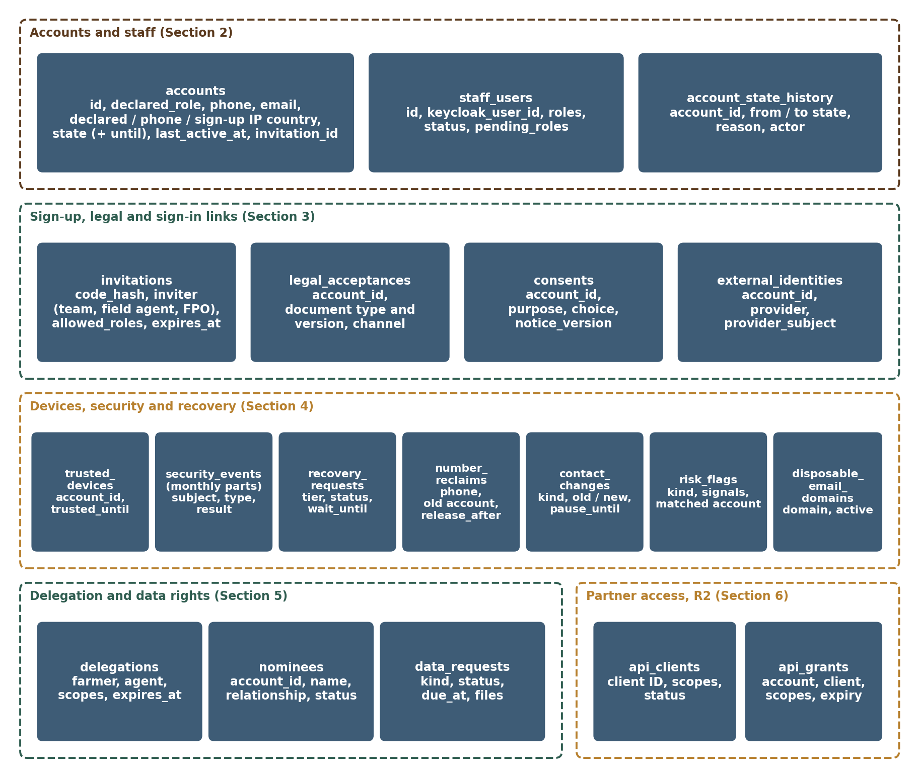
Figure 1 — Module 2 data model (overview)

1.3 How to read the table diagrams
The marks used in the table diagrams (PK, FK, ref, one / many, optional / required, dashed lines) are explained in the diagram key of the Master Database Design, Section 1.3. Diagrams show the main columns; the full column list is in each table below.

2. Accounts and Staff
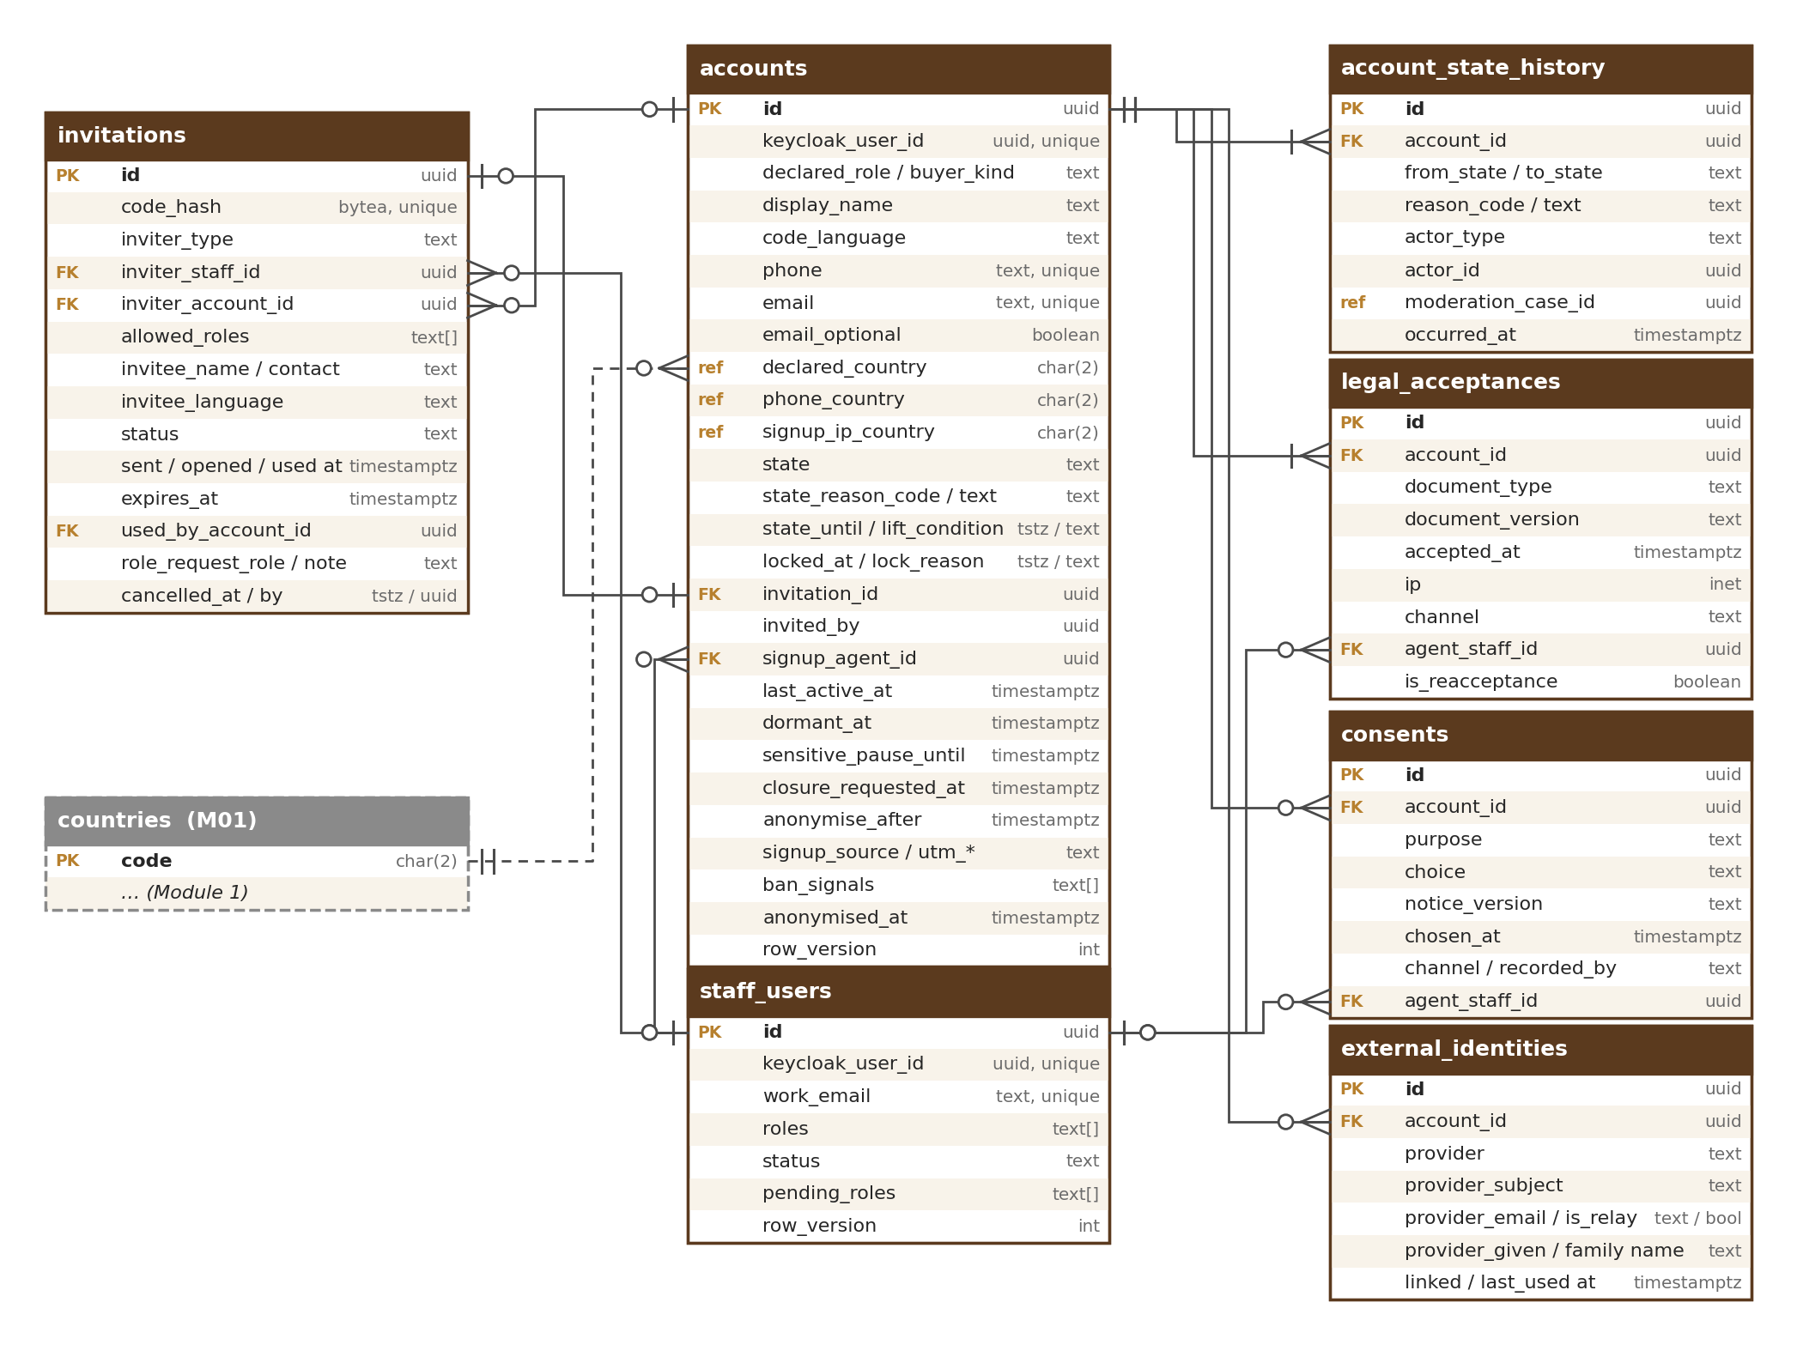
Figure 2 — Accounts, staff, sign-up and legal tables

2.1 accounts
One row per person who can sign in to the marketplace (users realm). The profile shown on the marketplace belongs to Module 3.
Column | Type | Notes
id | uuid PK | The account ID every module uses
keycloak_user_id | uuid | UNIQUE; the user in the Keycloak users realm
declared_role | text | buyer, seller, company, nursery, inoculation_provider, farmer (check); the exact role chosen at sign-up (SUP-016), limited by invitations.allowed_roles when an invitation is used. M03 creates the role on the profile from it; later role changes live in M03
declared_buyer_kind | text | individual, business (check); only when declared_role = buyer (check), otherwise null
display_name | text | Display name used only for greetings and account screens (messages and enquiries show the M03 profile’s public name: store name for business roles, the farmer’s display name, the buyer’s name as on the buyer profile — M03 PRF-015), any script; length ≤ 100 (check). Filled at sign-up from “Your full name (as on your ID)”, which is also copied once (through account.created) to the M03 profile legal name, profiles.person_legal_name — the only place the legal name is kept. The user can change the display name on the personal details screen (CHG-007)
code_language | text | Language for codes and calls (code SMS, WhatsApp and voice calls — OTP-012, OTP-014; M02-6 Section 17), e.g. en, hi, as, bn; null = same as the app language in M01 user_preferences. Owned by M02 (CHG-007)
profile_photo_file_id | uuid (ref) | Optional personal photo; private M01 file (CHG-007)
phone / phone_confirmed_at | text / timestamptz | International format (+91…); UNIQUE among accounts that are not anonymised (partial index) — one number, one account (SUP-005). Null only after a number reclaim released it (check: phone is set unless phone_released_at is set or the row is anonymised)
phone_released_at | timestamptz | When a number reclaim took the number off this account (REC-012); the owner must add a new number at the next sign-in
phone_undeliverable_at / email_bounced_at | timestamptz / timestamptz | From M13 delivery events; drive the “We can’t reach you” notice; cleared on the next successful delivery or change; never block (NTF-007)
phone_line_type | text | mobile, voip, unknown — from the number-type lookup [TBC: lookup supplier]; voip raises a risk flag (RSK-008)
email / email_confirmed_at | text / timestamptz | Lower-case; UNIQUE when present (partial index); null only when email_optional
email_optional | boolean | True for farmers (SUP-002)
email_is_private_relay | boolean | Email is an Apple “Hide my email” relay address (SIN-011)
password_set | boolean | False for Google or Apple accounts without a password; copy of the Keycloak credential state kept in step by the event listener (SIN-013)
declared_country | char(2) (ref) | Account country the user declares (SAN-001); code from platform.countries
phone_country / signup_ip_country | char(2) (ref) / char(2) (ref) | Country of the phone number and of the sign-up IP address (CDN country header)
has_country_difference | boolean | True when the three countries differ; shown to staff (SAN-002)
state | text | active, deactivated, dormant, suspended, banned, closed (check); every change also in account_state_history
state_reason_code / state_reason_text | text / text | e.g. user_request, idle_12_months, under_18, scam; text shown to the user for suspended and banned accounts with the appeal link
state_changed_at | timestamptz
state_until / state_lift_condition | timestamptz / text | End date or lifting condition of a suspension, from moderation.account_action (ACC-010); null for other states and for bans
moderation_case_id | uuid (ref) | M12 case behind the current suspension or ban; used to build the appeal link
locked_at / lock_reason | timestamptz / text | failed_signins or this_wasnt_me; a lock is not a state (M02-2 Section 8); cleared by unlock or recovery
failed_signin_count | int | Failures since the last successful sign-in; 20 → lock (RSK-003). The fast counters for delays are in Redis
two_step_method | text | none, authenticator (passkey from R2). Copy of the Keycloak credential state, kept in step by the Keycloak event listener; used for screens and for the token claim
invitation_id | uuid FK → invitations | Invitation used at sign-up; null when the person signed up without one (SUP-008)
invited_by | uuid | Inviter (staff user or account, as in invitations.inviter_type); kept for “who invited whom” reports
signup_channel | text | web, app, field_agent
signup_agent_id | uuid FK → staff_users | Field agent who filled the form (DEL-001); null otherwise
signup_district | text (ref) | District code from platform.country_districts, collected on the field-agent form (M02-4 Section 8.3); null otherwise
signup_locale / signup_platform | text / text | Browser or device language at sign-up (BCP 47, e.g. as-IN) / web, android, ios with app version (SUP-028)
bot_check_mode | text | normal, fallback, agent (check) — how sign-up was protected (RSK-011, DEL-010)
signup_source / referrer_url / landing_page | text / text / text | invitation, field_agent, fpo_invitation, seller_link, direct (check; the values waitlist_invitation and founding_seller were removed on 24 Sep 2026: open sign-up) / referring page / first page (SUP-029)
referring_profile_id | uuid (ref) | M03 profile of the seller whose share link the person used (signup_source seller_link, SUP-032); kept for Founding Seller benefits (M11); null otherwise. A column is used, not the referrer data, so the link survives a store rename
utm_source / utm_medium / utm_campaign | text | Campaign tags read from the address at sign-up (no cookie); counted in M18
how_heard | text | Optional self-reported answer: trade_fair, whatsapp_group, field_agent, fpo, search, friend, other (check)
first_signin_at | timestamptz | First successful sign-in (SUP-028)
accepted_terms_version / accepted_privacy_version | text / text | Copy of the latest legal_acceptances rows, compared with the current M17 versions at sign-in (PRV-004)
last_active_at | timestamptz | Updated at sign-in and on user actions, at most once per hour per account to limit writes (ACC-003)
dormant_at / dormant_reminders_sent | timestamptz / smallint | When the account became dormant; reminders sent: 0, 1 (30 days before), 2 (7 days before)
sensitive_pause_until | timestamptz | End of the 72-hour pause after a phone or email change (CHG-004); copy of the latest contact_changes.pause_until
closure_requested_at / anonymise_after | timestamptz / timestamptz | Closure with 30-day grace (ACC-006); the anonymise job runs after anonymise_after
ban_signals | text[] | Keyed hashes (HMAC) of device IDs, phone and email patterns, IP ranges and M03 document numbers; filled only when the account is banned; cleared after the retention period [TBC: C10] (RSK-009)

Data level: Confidential (name, phone, email, countries, IP-derived country, sign-up source, referring page and referring seller); ban_signals is derived from Restricted data and holds only keyed hashes. Retention: kept while the account exists; after the 30-day closure grace the row keeps its ID, state and declared_role but loses name, photo, phone, email, sign-up source, referring seller, referring and landing pages, how_heard and ban_signals (anonymised_at set; Master Database Design, Section 8.3). Indexes: UNIQUE partial (phone) and (email) where anonymised_at is null; (state, last_active_at) for the dormant job; (anonymise_after) partial where state = closed; partial (state_until) where state = suspended; partial (referring_profile_id) where not null; GIN (ban_signals). The browser language and time zone saved at sign-up are stored in M01 user_preferences (language, time_zone and how the time zone was set), not here.

2.2 staff_users
OudhTrade staff in the separate staff realm (Super Admin, Admin, Moderator, Finance, Content Editor, Support, Field Agent — STF-001). Staff never use accounts.
Column | Type | Notes
id | uuid PK
keycloak_user_id | uuid | UNIQUE; the user in the Keycloak staff realm
display_name | text | Shown in audit records and, for field agents, to farmers (e.g. “R. Das”)
work_email | text | UNIQUE; company domain only (check); field agents of approved partners use an address issued by OudhTrade (starting rule, configurable)
work_phone | text | For emergencies only; never used for sign-in codes (STF-002)
roles | text[] | super_admin, admin, moderator, finance, content_editor, support, field_agent (check)
status | text | invited, active, suspended, left (check)
pending_roles / role_requested_by / role_requested_at | text[] / uuid / timestamptz | A role change waiting for the second approver (STF-006)
role_approved_by / role_approved_at | uuid / timestamptz | Check: role_approved_by differs from role_requested_by
requires_security_key | boolean | True for super_admin and finance (STF-003)
is_emergency | boolean | The two sealed emergency Super Admin accounts (STF-009)
joined_on / left_on | date / date | Leaver: all access and sessions removed the same day (STF-010)
access_reviewed_at / access_reviewed_by | timestamptz / uuid | Last quarterly access review (STF-008)
last_signin_at | timestamptz | For the access review

Data level: Confidential. Retention: kept 1 year after left_on, then name and contacts anonymised [TBC: C10]; the ID stays because the audit log refers to it. Field-agent details (region, partner) are in the Module 3 table field_agents, which refers to staff_users by ID.

2.3 account_state_history
Append-only history of every state change (ACC-001).
Column | Type | Notes
id | uuid PK
account_id | uuid FK → accounts
from_state / to_state | text / text | Same values as accounts.state
reason_code / reason_text | text / text | As on accounts
actor_type / actor_id | text / uuid | user, staff, moderation (M12), system; account, staff user or fixed system ID
moderation_case_id | uuid (ref) | M12 case when the change came from moderation.account_action
occurred_at | timestamptz

Data level: Confidential. Retention: kept as long as the account row (evidence for appeals and legal orders); reason_text is cleared at anonymisation, codes stay. Index: (account_id, occurred_at).

3. Sign-up, Legal Acceptances and Sign-in Links
These tables are shown in the diagram in Section 2.

3.1 invitations
Invitation links and codes from our team (Admin), field agents and FPOs; sign-up itself is open and needs no invitation (SUP-008 to SUP-012, SUP-018 to SUP-022).
Column | Type | Notes
id | uuid PK
code_hash | bytea | UNIQUE; keyed hash of the 16-character code (Crockford base-32, no look-alike characters — SUP-020), normalised before hashing. The code itself is only in the link or message and is never stored
code_hint | text | First 4 characters, so Support can find an invitation
inviter_type | text | admin, field_agent, fpo (check; founding_seller removed on 24 Sep 2026)
inviter_staff_id | uuid FK → staff_users | Admin or field agent
inviter_account_id | uuid FK → accounts | FPO account (Company with the Co-operative / FPO badge, checked through M03 when inviting); check: exactly one of the two inviter columns is set
allowed_roles | text[] | One or more of buyer, seller, company, nursery, inoculation_provider, farmer (check, not empty); field_agent and fpo invitations only farmer (check) (SUP-018)
invitee_name / invitee_contact | text / text | Optional; used to send the link; cleared 30 days after use or expiry
invitee_language | text | Language of the invitation and its reminders (NTF-008)
reminders_sent / last_reminder_at | smallint / timestamptz | 0, 1 (day 3), 2 (2 days before expiry) (NTF-008)
role_request_role / role_request_note / role_requested_at | text / text / timestamptz | “This isn’t my role” request (SUP-019); one open request per invitation
role_request_decision / role_request_decided_by | text / uuid | approved, refused (check) / staff user or FPO account who answered
replaced_by_invitation_id | uuid FK → invitations | Corrected invitation issued after an approved role request
waitlist_entry_id | — | Removed (24 Sep 2026): open sign-up; column not built
status | text | sent, opened, used, expired, cancelled, replaced (check)
sent_at / opened_at / used_at | timestamptz
expires_at | timestamptz | sent_at + 14 days (configurable)
used_by_account_id | uuid FK → accounts | UNIQUE; single use
cancelled_at / cancelled_by | timestamptz / uuid | Inviter or Admin

Data level: Confidential (invitee contact). Retention: used invitations are kept while the invited account exists (who invited whom); unused, expired or cancelled invitations are deleted 12 months after expiry. The FPO open-invitation limit (SUP-009) counts only rows per inviter_account_id with status sent or opened (not past expires_at); used, expired, cancelled and replaced rows give the place back (SUP-021). The default of 50 can be raised by Admin for one FPO (SUP-009). Indexes: (inviter_account_id, status); (inviter_staff_id, status); (status, expires_at); partial (role_requested_at) where role_request_decision is null.

3.2 waitlist_entries (removed)
Removed (24 Sep 2026): open sign-up. This table is not built; sign-up needs no invitation (M02-1 decision 59).

3.3 legal_acceptances
Append-only proof of each required agreement line an account accepted at sign-up (one row per line, with its version), of the 18+ declaration and of re-acceptance of the Terms of Use and Privacy Notice (SUP-004, SUP-027, SUP-031, PRV-004).
Column | Type | Notes
id | uuid PK
account_id | uuid FK → accounts
document_type | text | terms, privacy, data_processing_consent, grievance_notice, off_platform_notice, age_declaration (check; the R1-only terms value was removed on 24 Sep 2026: open sign-up). age_declaration stores the version of the “I am 18 or over” text; only terms and privacy are accepted again after a material change
document_version | text | Version of the M17 legal document (stored by value)
accepted_at | timestamptz
ip | inet | Cleared at anonymisation
channel | text | web, app, field_agent
agent_staff_id | uuid FK → staff_users | Field agent present at a farmer sign-up (DEL-003)
text_language | text | Language of the line shown or read out (en, hi, as, bn — DEL-012)
is_reacceptance | boolean | True when accepted again after a material change

Data level: Confidential. Retention: for the life of the account and [TBC: C10] after closure as proof; IP removed at anonymisation. Index: (account_id, document_type, accepted_at).

3.4 consents
Append-only record of consent choices for five purposes: marketing_email, marketing_sms, marketing_whatsapp, personalised_promotions (personalised sponsored placements, used from R2, stored from R1), ai_assist_own_listings (PRV-001, PRV-002). marketing_email and personalised_promotions can also be given on the sign-up agreements step (SUP-031; “Send me market updates” = marketing_email only); marketing_sms and marketing_whatsapp are separate Settings switches (the earlier single marketing_sms_whatsapp value is replaced). One row per change; the current choice is the newest row per account and purpose.
Column | Type | Notes
id | uuid PK
account_id | uuid FK → accounts
purpose | text | marketing_email, marketing_sms, marketing_whatsapp, personalised_promotions, ai_assist_own_listings (check)
choice | text | given, withdrawn
notice_version | text | Privacy Notice or consent text version shown
chosen_at | timestamptz
channel / recorded_by | text / text | web, app, field_agent / user, field_agent
agent_staff_id | uuid FK → staff_users | When a field agent recorded the farmer’s consent (DEL-003)
text_language | text | Language of the consent text shown or played (en, hi, as, bn — DEL-012)
ip | inet | Cleared at anonymisation

Optional analytics cookies are stored only in platform.cookie_consents (M01), as the account-level cookie choice; the Settings page reads and writes it through the M01 consent service, so the fact lives in one place. Data level: Confidential. Retention: for the life of the account and [TBC: C10] after closure as proof of consent. Index: (account_id, purpose, chosen_at desc).

3.5 external_identities
Google and Apple sign-in links (SIN-005 to SIN-007). Keycloak keeps its own broker link; this table is the account-side record used by the Settings page and Support, kept in step by the Keycloak event listener.
Column | Type | Notes
id | uuid PK
account_id | uuid FK → accounts | UNIQUE (account_id, provider)
provider | text | google, apple (check)
provider_subject | text | The provider’s user ID; UNIQUE (provider, provider_subject)
provider_email | text | Email given by the provider (Apple may give a private relay address); never used to link an account (SIN-006)
provider_email_is_relay | boolean | True for an Apple private relay address (SIN-011)
provider_given_name / provider_family_name | text / text | Name Apple sends only on the first sign-in, saved at once (SIN-011)
linked_at / last_used_at | timestamptz

Data level: Confidential. Retention: row deleted on unlink (the security event stays) and at anonymisation.

4. Devices, Security, Recovery and Risk
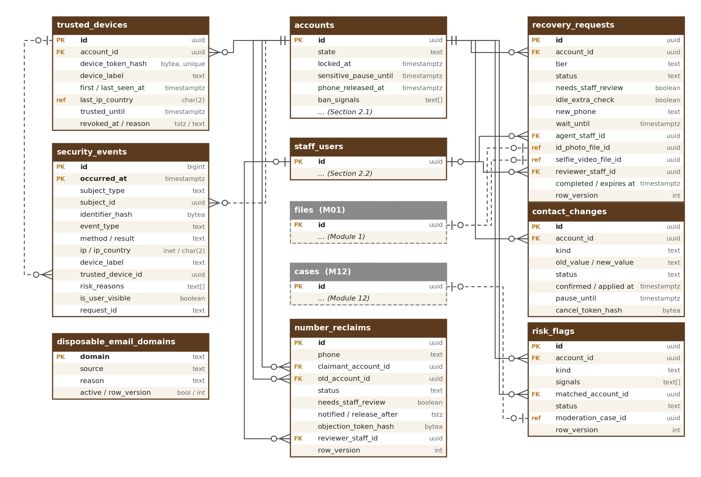
Figure 3 — Devices, security events, recovery, number reclaims, contact changes and risk flags

4.1 trusted_devices
“Remember this device” for 30 days (SES-006).
Column | Type | Notes
id | uuid PK
account_id | uuid FK → accounts
device_token_hash | bytea | UNIQUE; keyed hash of the random value in the device cookie (M02-3 Section 7)
device_label | text | e.g. “Chrome on Android”
first_seen_at / last_seen_at | timestamptz
last_ip_country | char(2) (ref)
trusted_until | timestamptz | Last trust + 30 days (configurable)
revoked_at / revoked_reason | timestamptz / text | user, forgotten (“Forget this device”, SES-011), password_change, recovery, this_wasnt_me, signed_out_all

Data level: Confidential. Retention: deleted 30 days after trusted_until or revoked_at. Index: (account_id, trusted_until).

4.2 security_events
User-visible sign-in and security history and the security event log (RSK-005, SES-008). Append-only; partitioned by month on occurred_at.
Column | Type | Notes
id | bigint identity | PK (id, occurred_at) — partitioned tables include the partition key in the primary key
occurred_at | timestamptz | Partition key (month)
subject_type | text | account, staff_user, unknown (a failed attempt for a phone or email with no account)
subject_id | uuid | Account or staff user; no database constraint on this log
identifier_hash | bytea | Keyed hash of the typed phone or email when there is no subject — never the value itself
event_type | text | signin_succeeded, signin_failed, risk_code_asked, code_failed, new_device, new_country, soft_lock, account_locked, account_unlocked, password_changed, contact_changed, country_changed, two_step_changed, recovery_started, recovery_completed, token_reuse, signed_out_all, this_wasnt_me, delegation_granted, delegation_revoked, api_grant_changed, signup_refused_country, emergency_account_used, device_forgotten, bot_check_fallback, number_reclaim_requested, number_reclaim_objected, number_released (check)
method / result | text / text | password, google, apple, authenticator, passkey, sms, whatsapp, email / ok, failed, challenged, blocked
ip / ip_country | inet / char(2)
device_label / trusted_device_id | text / uuid | Device shown on the history page
risk_reasons | text[] | new_device, new_country, failures, bad_ip, voip…
is_user_visible | boolean | Shown on the user’s security page
request_id | text | Links to logs

Data level: Confidential (IP address, device). Retention: 12 months in the database (monthly partitions older than 12 months are dropped). Every event is also written to the security log stream, kept at least 180 days in the log archive in India (CERT-In; M01 OBS rules). Indexes: (subject_id, occurred_at desc) partial where is_user_visible; (event_type, occurred_at); (identifier_hash, occurred_at).

4.3 recovery_requests
Account recovery requests, their checks and waiting periods (REC-001 to REC-009). A request is stored only when an account matches; the answer to the user is the same either way.
Column | Type | Notes
id | uuid PK
account_id | uuid FK → accounts
tier | text | forgot_password, lost_phone, id_check (check)
status | text | started, code_sent, waiting, in_review, approved, rejected, completed, cancelled, expired (check)
needs_staff_review | boolean | Verified seller (REC-006) or ID check
idle_extra_check | boolean | Account idle 90 days or more: phone code alone not enough (REC-007)
started_ip_country | char(2) (ref)
new_phone | text | Lost phone: the new number, active only after the wait
wait_until | timestamptz | 72 hours after the new number is confirmed (REC-003)
cancel_token_hash | bytea | Keyed hash of the “Cancel this change” link sent to the old contacts
agent_staff_id | uuid FK → staff_users | Field agent or Support person who opened the ID-check case and uploaded the files; never the decider (REC-004)
staff_notes | jsonb | Notes added by Support, field agents or reviewers: time, staff ID, text; never shown to the user (STF-012)
id_photo_file_id / selfie_video_file_id | uuid (ref) / uuid (ref) | Private files in Module 1; deleted after the decision (retention policy recovery_id_media) [TBC: C10]
reviewer_staff_id / reviewed_at / review_note | uuid FK → staff_users / timestamptz / text | Staff decision; the reviewer never sees or sets a password (REC-009)
completed_at / expires_at | timestamptz | Unfinished requests expire: 24 hours (tiers 1 and 2), 7 days (ID check), configurable

Data level: Confidential; the ID photo and video are Restricted and live only as private files in Module 1. Retention: 12 months after completion or expiry, then deleted [TBC: C10]; the audit log keeps the decision. Indexes: (account_id, created_at); (status, needs_staff_review) for the staff queue; (wait_until) partial where status = waiting.

4.4 contact_changes
Phone, email and account-country changes with the cooling-off pause (CHG-001 to CHG-006).
Column | Type | Notes
id | uuid PK
account_id | uuid FK → accounts
kind | text | phone, email, account_country (check)
old_value / new_value | text / text | Phone, email or country code
status | text | pending_confirmation, applied, cancelled, expired, refused (check)
confirmed_at / applied_at | timestamptz
pause_until | timestamptz | applied_at + 72 hours for phone and email (configurable)
cancel_token_hash | bytea | Keyed hash of the “This wasn’t me” link sent to the old contact
cancelled_at / cancelled_via | timestamptz / text | user, old_contact, staff
refusal_reason | text | e.g. contact_in_use, blocked_country — internal; the user sees the neutral message

Data level: Confidential. Retention: 12 months, then deleted; the audit log keeps the change record. Index: (account_id, created_at) — also used for the limit of 3 changes per 30 days.

4.5 risk_flags
Account-takeover and ban-evasion signals for staff review in M12 (RSK-008, RSK-009, SAN-002, SAN-004). A flag never blocks by itself.
Column | Type | Notes
id | uuid PK
account_id | uuid FK → accounts
kind | text | ban_evasion_match, voip_number, country_difference, takeover_suspected, token_reuse, blocked_country_link, code_pumping_suspected (check)
signals | text[] | Which signal types matched (device, email_pattern, phone_pattern, ip_range, document_number) — never the values
matched_account_id | uuid FK → accounts | Banned account that matched (ban evasion)
score | numeric(5,2) | Strength of the match, for sorting the review queue
status | text | open, sent_to_review, no_action, action_taken (check)
moderation_case_id | uuid (ref) | M12 case created from account.risk_flagged
raised_at / reviewed_at | timestamptz

Data level: Confidential. Retention: 12 months after the flag is closed [TBC: C10]. Indexes: (status, raised_at); (account_id); (matched_account_id).

4.6 disposable_email_domains
Admin-managed list of throw-away email domains refused at sign-up and on email change (RSK-007).
Column | Type | Notes
domain | text PK | Natural key (Section 1.1); lower-case, e.g. mailinator.com
source | text | import (a list file), admin
reason | text | Why the domain was added or retired (required, M02-6 Section 20.7)
active | boolean | Retire, never delete (a wrongly listed domain is set inactive)

Data level: Internal. Retention: reference data, retired never deleted. Managed in its settings screen with the common settings pattern (M01-6 Section 12.1); the M01 configuration import is another way to publish it.

4.7 number_reclaims
Requests from the new holder of a recycled mobile number to release it from an old account (REC-010 to REC-013). The claimant has no account yet (or is changing the phone of another account), so the claimant is stored by phone number and, when known, account.
Column | Type | Notes
id | uuid PK
phone | text | The number in international format; UNIQUE partial where status in (waiting, in_review) — one open reclaim per number
claimant_proved_at | timestamptz | When the claimant typed the code sent to the number
claimant_account_id | uuid FK → accounts | Set when the claimant is an existing account changing its phone, or once the claimant’s sign-up finishes
claimant_ip_country / claimant_contact | char(2) (ref) / text | Email the claimant gave for the outcome message (optional); cleared 30 days after the decision
old_account_id | uuid FK → accounts | The account the number is on
old_account_idle_days | int | Days since old_account last_active_at when asked; must be ≥ 90 (configurable, REC-011)
status | text | waiting, in_review, released, objected, refused, expired, cancelled (check)
needs_staff_review | boolean | Old account has no confirmed email, has a verified seller profile, or is suspended, banned or closing (REC-013)
notified_at / release_after | timestamptz / timestamptz | Email to the old account; release_after = notified_at + 7 days (configurable)
objection_token_hash | bytea | Keyed hash of the “This is still my number” link
objected_at / released_at | timestamptz / timestamptz
staff_notes | jsonb | Notes and contact attempts added by Support, field agents or reviewers: time, staff ID, text; never shown to the claimant or the old owner (STF-012)
reviewer_staff_id / review_note | uuid FK → staff_users / text | Staff decision when needs_staff_review (Admin or Super Admin)
decided_at | timestamptz

Data level: Confidential. Retention: 12 months after the decision, then deleted [TBC: C10]; the audit log keeps the decision. Indexes: UNIQUE partial (phone) where status in (waiting, in_review); (status, release_after) for the release job; (old_account_id); (claimant_account_id).

5. Delegation, Nominee and Data Requests
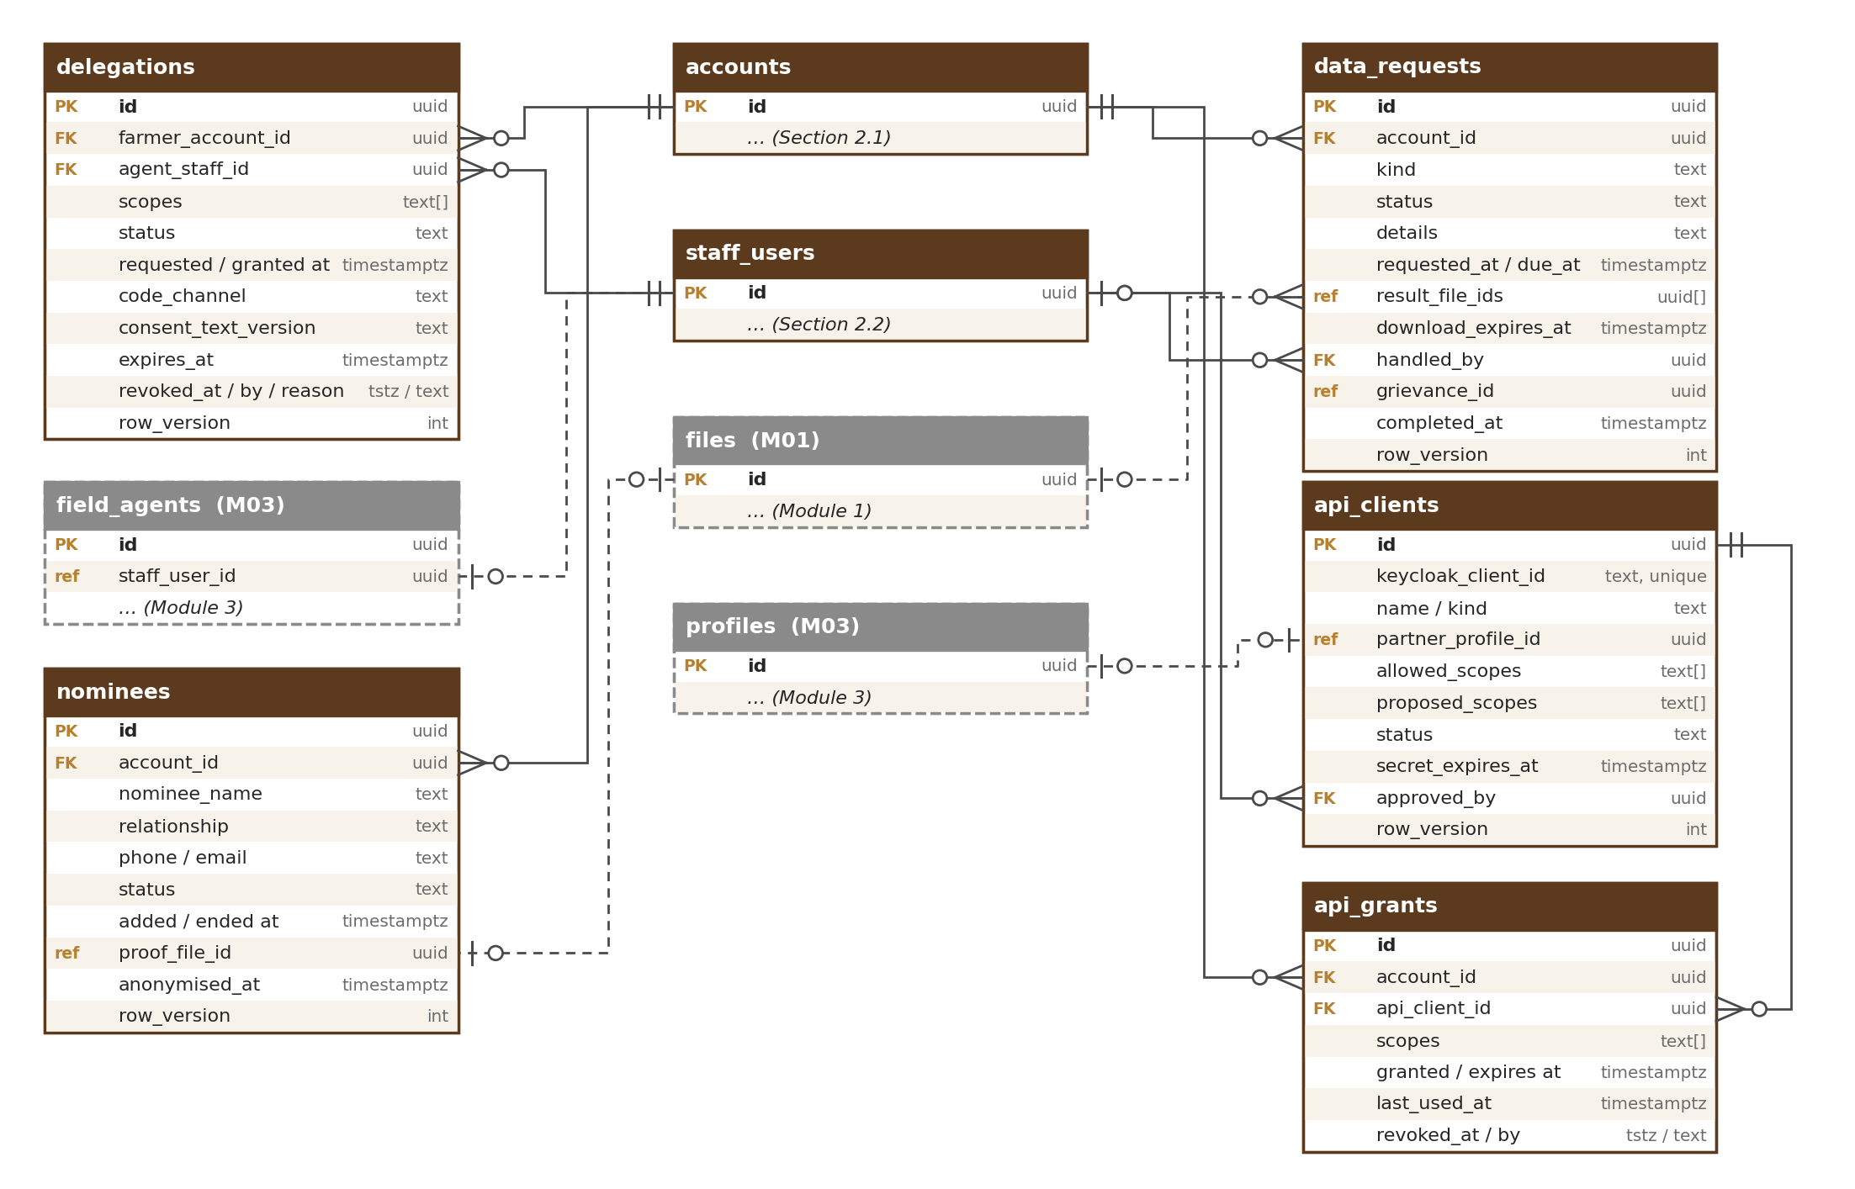
Figure 4 — Delegation, nominee, data requests and partner access tables

5.1 delegations
Farmer-approved rights for a field agent (DEL-006 to DEL-009).
Column | Type | Notes
id | uuid PK
farmer_account_id | uuid FK → accounts | Must be a farmer account (checked by DelegationService)
agent_staff_id | uuid FK → staff_users | Field agent (role field_agent)
scopes | text[] | listing_draft_edit, photo_upload, farm_profile_edit, verification_upload (check: one or more of these four; nothing else in R1)
status | text | requested, active, expired, revoked, declined (check)
requested_at / granted_at | timestamptz | granted_at = when the farmer typed the correct code
code_channel | text | sms, whatsapp
consent_text_version | text | Version of the plain-words text shown and read out
expires_at | timestamptz | granted_at + 30 days (configurable)
revoked_at / revoked_by_type / revoke_reason | timestamptz / text / text | farmer, staff, system (expired, account not active)

Data level: Confidential. Retention: for the life of the farmer account and [TBC: C10] after closure, as proof of what the agent was allowed to do. Every agent action is in the audit log with both IDs. Indexes: UNIQUE partial (farmer_account_id, agent_staff_id) where status in (requested, active); (agent_staff_id, status); (status, expires_at).

5.2 nominees
Nominee named by a user under the DPDP Act (PRV-005).
Column | Type | Notes
id | uuid PK
account_id | uuid FK → accounts | UNIQUE partial where status = active — one active nominee
nominee_name / relationship | text / text
phone / email | text / text | At least one (check)
status | text | active, replaced, removed, invoked (check)
added_at / ended_at | timestamptz
invoked_at / proof_file_id | timestamptz / uuid (ref) | When the nominee acted and the proof file in Module 1; proof rules [TBC: counsel]

Data level: Confidential (another person’s data). Retention: kept while the account exists; anonymised with the account, unless the nominee has invoked the right [TBC: counsel].

5.3 data_requests
Download, correction and deletion requests with timers (PRV-006 to PRV-008, ACC-006).
Column | Type | Notes
id | uuid PK
account_id | uuid FK → accounts
kind | text | download, correction, deletion (check); deletion is the account closure
status | text | received, in_progress, ready, failed, completed, rejected, cancelled (check); failed is shown as “Failed — we’re fixing it” while retries run (PRV-012)
details | text | What to correct (correction); optional closure reason (deletion — ACC-012)
failure_reason / retry_count | text / smallint | Internal reason when an export fails; retries so far (PRV-012)
requested_at / due_at | timestamptz | due_at = requested_at + 7 days (download, correction; configurable) or the end of the closure grace (deletion)
result_file_ids | uuid[] (ref) | Private files in Module 1: JSON, CSV and PDF summary
download_expires_at | timestamptz | 7 days after ready; files deleted then
handled_by | uuid FK → staff_users | Staff member for corrections and problems
staff_reminded_at | timestamptz | Last reminder before the due date
grievance_id | uuid (ref) | M12 grievance, if the user complained
completed_at / rejection_reason | timestamptz / text

Data level: Confidential. Retention: 3 years after completion as proof that the request was handled [TBC: C10]; export files are deleted at download_expires_at. Indexes: (account_id, requested_at); (status, due_at) for timers.

6. Partner and AI-Agent Access
These tables are shown in the diagram in Section 5. Client secrets are held only in Keycloak and shown once when created. Screens: M02-6 Sections 12.1, 12.2 and 20.8.

6.1 api_clients
Approved partner and AI-agent clients (API-001, API-002).
Column | Type | Notes
id | uuid PK
keycloak_client_id | text | UNIQUE; the client in the Keycloak users realm
name / kind | text / text | partner, ai_agent (check)
partner_profile_id | uuid (ref) | M03 profile of the approved partner
allowed_scopes | text[] | e.g. listings.read, listing_drafts.write
status | text | waiting_approval, active, suspended, revoked (check)
proposed_scopes / proposed_by / proposed_at | text[] / uuid FK → staff_users / timestamptz | A scope change waiting for approval (high-impact, M01-6 Section 12.1); cleared when approved or rejected; the approver can never be proposed_by (API-006)
key_notice_email | text | Partner contact for key expiry and rotation notices
secret_rotated_at / secret_expires_at | timestamptz | Rotation reminders before expiry (API-004)
old_secret_valid_until | timestamptz | End of the rotation overlap (24 hours, configurable); null when the old key was stopped at once (API-006)
suspended_at / suspended_by / suspend_reason | timestamptz / uuid FK → staff_users / text | While suspended every call is refused and grants are paused (API-006)
rate_limit_group | text | Action group registered in platform.rate_limit_policies (API-005)
approved_by / approved_at | uuid FK → staff_users / timestamptz
revoked_at / revoked_by | timestamptz / uuid

Data level: Internal (the secret itself, Restricted, is only in Keycloak). Retention: kept 2 years after revocation [TBC: counsel C10].

6.2 api_grants
A user’s consent to a partner or AI-agent client acting for them (API-003, API-004).
Column | Type | Notes
id | uuid PK
account_id | uuid FK → accounts
api_client_id | uuid FK → api_clients | UNIQUE partial (account_id, api_client_id) where revoked_at is null
scopes | text[] | Only scopes the client is allowed
consent_screen_version | text
granted_at / expires_at | timestamptz | Expiry 90 days after granted_at (configurable, API-007)
last_used_at | timestamptz | Last call made with this grant; shown under Connected apps (API-008)
revoked_at / revoked_by_type | timestamptz / text | user, admin, system

Data level: Confidential. Retention: 12 months after revocation or expiry, then deleted.

7. Links to Other Modules
Module 2 tables hold only the IDs of records that belong to other modules (ref). There are no database foreign keys across modules. The owning module keeps the link correct through its interface and events.
Module 2 column | Points to | Owner
accounts.declared_country, phone_country, signup_ip_country; trusted_devices.last_ip_country; recovery_requests.started_ip_country; number_reclaims.claimant_ip_country | countries.code | M01
accounts.signup_district | country_districts | M01
recovery_requests.id_photo_file_id, selfie_video_file_id; nominees.proof_file_id; data_requests.result_file_ids; accounts.profile_photo_file_id | files | M01
accounts.moderation_case_id; account_state_history.moderation_case_id; risk_flags.moderation_case_id | moderation cases | M12
data_requests.grievance_id | grievances | M12
api_clients.partner_profile_id | profiles | M03
legal_acceptances.document_version; consents.notice_version | legal document versions (by value) | M17
api_clients.rate_limit_group | rate_limit_policies (by value) | M01

Other modules point to Module 2 as follows (their designs confirm the column names):
Other module column | Points to | Module
created_by / updated_by of every table; audit_log.actor_id; profile_members.account_id; listings, messages and reviews “done by” columns | accounts or staff_users | All
field_agents.staff_user_id | staff_users | M03
user_preferences.account_id (M02 writes language and time_zone at sign-up and from the personal details screen, with how the time zone was set in time_zone_source — M01-5 Section 4.2), cookie_consents.account_id, ai_requests.account_id, idempotency_keys.caller_id, files.owner_account_id | accounts | M01
Listing drafts made under delegation (delegation ID and agent ID on the listing version) | delegations, staff_users | M05
moderation cases about an account; risk-flag reviews | accounts, risk_flags | M12

Table names of other modules are planned names; they are confirmed in each module’s database design. Module 2 uses no shared-link (“type + ID”) columns; the audit log’s shared link to Module 2 records uses the target types account and staff_user (M01-5 Section 11.1).

8. Retention Summary
Retention periods are registered in the Module 1 retention engine (platform.retention_policies) and run by its daily job, except the partition drop of security_events, which Module 2 schedules itself. Final periods are confirmed by counsel (C10).
Table | Kept | Then
accounts | While the account exists; 30-day grace after closure | Anonymised (ID and state kept)
staff_users | 1 year after leaving [TBC: counsel C10] | Anonymised (ID kept for the audit log)
account_state_history | As long as the account row | reason_text cleared at anonymisation
invitations | Used: while the invited account exists. Others: 12 months after expiry | Deleted; invitee contact cleared 30 days after use or expiry
legal_acceptances, consents | Life of the account + [TBC: C10] | IP removed at anonymisation; rows deleted at the end
external_identities | Until unlinked or anonymised | Deleted
trusted_devices | 30 days after expiry or revoke | Deleted
security_events | 12 months in the database; ≥ 180 days in the security log archive | Monthly partition dropped
recovery_requests | 12 months after completion or expiry; ID media deleted after the decision | Deleted
contact_changes | 12 months | Deleted
number_reclaims | 12 months after the decision [TBC: C10]; claimant contact cleared 30 days after the decision | Deleted
risk_flags | 12 months after closing | Deleted
accounts.ban_signals | [TBC: C10] after the ban | Cleared
disposable_email_domains | Reference data | Retired, never deleted
delegations | Life of the farmer account + [TBC: C10] | Deleted
nominees | While the account exists | Anonymised with the account
data_requests | 3 years after completion [TBC: C10]; files 7 days | Deleted
api_clients · api_grants | 2 years after revoke [TBC: counsel C10] · 12 months after revoke or expiry | Deleted

A legal hold (M01) on an account stops all of the above for that account’s rows until the hold is released.

9. Rules
Module 2 follows the standards of the Master Database Design (naming, IDs and UUID version 7, standard columns, data types, schema as code, safe migrations, database users). Module 2 specifics:
- security_events is the only partitioned table (monthly, partition key occurred_at included in the primary key); future partitions are created by the monthly job, old ones dropped after 12 months.
- Foreign keys are enforced by the database inside Module 2 (except on the security_events log); links to other modules are ID references (ref) without database constraints.
- Phone numbers are stored in international format (E.164) and emails in lower case; uniqueness is enforced with partial unique indexes that ignore anonymised rows.
- Codes, tokens and links are never stored in plain form: invitation codes, device cookies, cancel links and reclaim objection links are kept as keyed hashes (HMAC with a key in AWS Secrets Manager). Plain one-time codes are never stored anywhere (M02-3 Section 7).
- Status and type columns are text with a check of allowed values (no enum types). Tables edited by people carry row_version; a save on a changed record is refused (M01-2 CFG-007).
- Personal-data columns are listed in the master data map and covered by retention policies (Section 8). The Aadhaar number is never stored. It is passed only to the licensed provider for the OTP check; we keep only the last 4 digits and the result (PRV-009; the Aadhaar check is in M03, and no M02 table has an Aadhaar column).

10. Indexes and Volumes
Main indexes and a year-1 row estimate for every Module 2 table. Every link column is indexed (Master Database Design, Section 9.3). Figures are estimates for design; load tests before R2 confirm them.
Table | Main indexes (besides the primary key) | Rows, year 1
accounts | UNIQUE (keycloak_user_id); UNIQUE partial (phone), (email) where not anonymised; (state, last_active_at); partial (anonymise_after); partial (state_until); (invitation_id); (signup_agent_id); (declared_role); partial (referring_profile_id); GIN (ban_signals) | ≈ 50,000 (estimate)
staff_users | UNIQUE (keycloak_user_id); UNIQUE (work_email); (status) | < 200
account_state_history | (account_id, occurred_at) | ≈ 80,000 (estimate)
invitations | UNIQUE (code_hash); UNIQUE (used_by_account_id); (inviter_account_id, status); (inviter_staff_id, status); (status, expires_at); (replaced_by_invitation_id); partial (role_requested_at) where undecided | ≈ 20,000 (estimate)
legal_acceptances | (account_id, document_type, accepted_at); (agent_staff_id) | ≈ 150,000 (estimate)
consents | (account_id, purpose, chosen_at desc); (agent_staff_id) | ≈ 150,000 (estimate)
external_identities | UNIQUE (provider, provider_subject); UNIQUE (account_id, provider) | ≈ 20,000 (estimate)
trusted_devices | UNIQUE (device_token_hash); (account_id, trusted_until) | ≈ 60,000 live (estimate)
security_events | (subject_id, occurred_at desc) partial where is_user_visible; (event_type, occurred_at); (identifier_hash, occurred_at) | ≈ 5 million a year (12 months kept) (estimate)
recovery_requests | (account_id, created_at); (status, needs_staff_review); partial (wait_until) | ≈ 10,000 (estimate)
contact_changes | (account_id, created_at); (status) | ≈ 10,000 (estimate)
number_reclaims | UNIQUE partial (phone) where open; (status, release_after); (old_account_id); (claimant_account_id) | ≈ 500 (estimate)
risk_flags | (status, raised_at); (account_id); (matched_account_id) | ≈ 5,000 (estimate)
disposable_email_domains | (active) | ≈ 5,000
delegations | UNIQUE partial (farmer_account_id, agent_staff_id) where requested or active; (agent_staff_id, status); (status, expires_at) | ≈ 2,000 (estimate)
nominees | UNIQUE partial (account_id) where active | ≈ 5,000 (estimate)
data_requests | (account_id, requested_at); (status, due_at) | ≈ 2,000 (estimate)
api_clients · api_grants | UNIQUE (keycloak_client_id) · UNIQUE partial (account_id, api_client_id); (api_client_id) | < 100 (estimate)

11. What Lives in Keycloak and Redis Instead
These data are deliberately not in the identity schema. Keycloak runs on its own small RDS PostgreSQL instance with its own backups, database user and cross-region replica in Hyderabad (HLD 5.2 and 6.1); Redis data is short-lived and can be lost without harm.
Data | Where | Notes
Passwords | Keycloak (users and staff realms) | Hashed with Argon2id; never in the identity schema, logs or staff screens (SIN-003)
Authenticator-app secrets (TOTP) | Keycloak | Users (optional) and all staff
Passkeys and security keys (WebAuthn) | Keycloak | Staff Super Admin and Finance from R1; users from R2
Backup codes (10 per user) | Keycloak (recovery codes) | Stored hashed; a new set replaces the old one (REC-005)
Sessions and refresh tokens | Keycloak | Rotation and reuse detection (SES-003, SES-004)
Google and Apple broker links | Keycloak | Mirrored in external_identities for screens and Support
Client secrets and realm signing keys | Keycloak (keys backed up in Secrets Manager) | Partner and AI-agent clients from R2
One-time code challenges | Redis | Keyed hash of the code, purpose, wrong tries and expiry (10 minutes); deleted when used (OTP-001, OTP-011)
Code send counters and daily cost per country | Redis (daily totals saved to M18 reports) | Per number: rolling 24 hours; cost per country: calendar day in UTC (OTP-003, OTP-008)
Failed sign-in counters, growing delays, IP and device blocks | Redis and platform.rate_limit_blocks (M01) | Counted per identifier (keyed hash of the mobile number or email, whether or not an account exists) and per IP / device (RSK-002, RSK-004); the durable 20-failure count is accounts.failed_signin_count
Recovery request counters | Redis | Per identifier (keyed hash), rolling 24 hours, whether or not an account exists (REC-002)
Code delivery status | M13 delivery events | OTP-010
Audit records of staff and agent actions | platform.audit_log (M01) | Support views, role changes, recovery decisions, agent actions with both names

